Project Documentation
What software Eng SE ?
- state of the art of developing quality software on time and
within budget
- Trade-off between perfection and physical constraints
- SE has to deal with real-world issues
- State of the art!
- Community decides on best practice + life-long education

What are SDLC( software dev life cycle ) & its rules?
- For project development rules & regulation need to be followed for best quality output at defined time limit
- Rules are Software Development Life Cycle – SDLC
- It‘s part of software engineering
- Six rules to be followed…

Project Rules & Regulation (SDLC) Software deve life cycle

6 RULES

- Requirement
- Analysis

Requirement analysis
Time requirement
Budget
How many users

Step 1: How many user work on website

  - Guest
  - Customer Website

  - Admin admin panel 100% manage
  - Employee employee panel 70% manage

===============================================================

Step 2: Define work of each user

  - Guest

Website visit
View product categories
View product
Contact us

  - Customer

Website visit
View product categories
View product
Contact us
Signup
Login
Manage profile
Add to cart
Manage cart
Make Order
Manage order
Feedback
Logout

===== Backend Panel

Login.php index
Dashboard
Table PAGE - All manage task
FORM PAGE – all add task

================== ONLY 4 PAGES

  - Employee

Signup by admin(add employee)
Login
Manage product categories add / upd / del Table/Form
Manage product T/F
Manage Contact us T
Manage Customer T
View cart report T
Manage Order T
View Feedback T
Logout

  - Admin

Login login
Manage product categories T/F
Manage product T/F
Manage Contact us T
Manage Customer T
View cart report T
Manage Order T
View Feedback T
Manage Employee T/F
Logout

========================================================================

Step 3: Define panel by user

Website: Guest / Customer

Employee panel: Employee
Admin Panel: Admin

50% planning clear

====================================================
Step 4: Define Some Diagram : Mysql Table/databse

- Use case Diagram
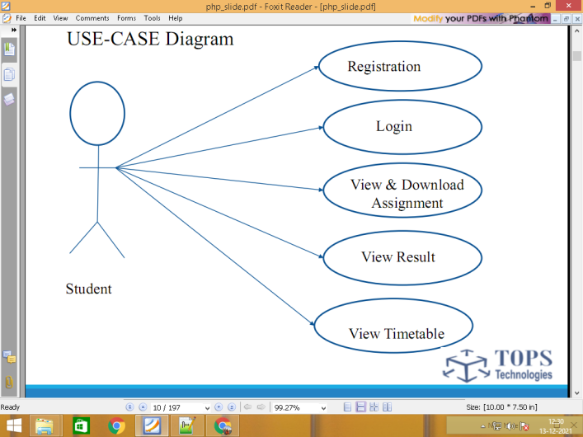

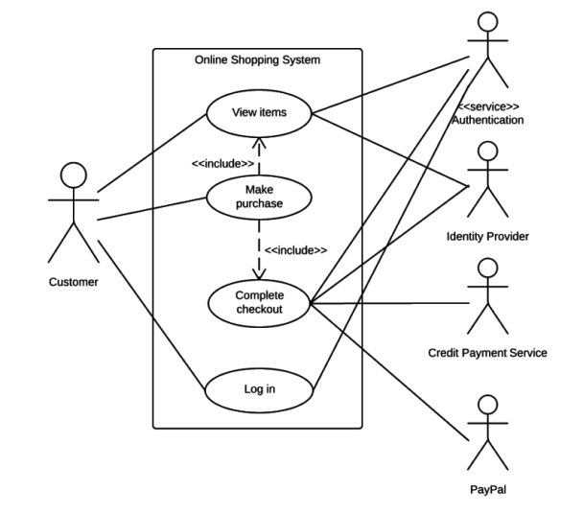
- DFD Data flow diagram level 0 / 1 / 2

0 level / context level diagram
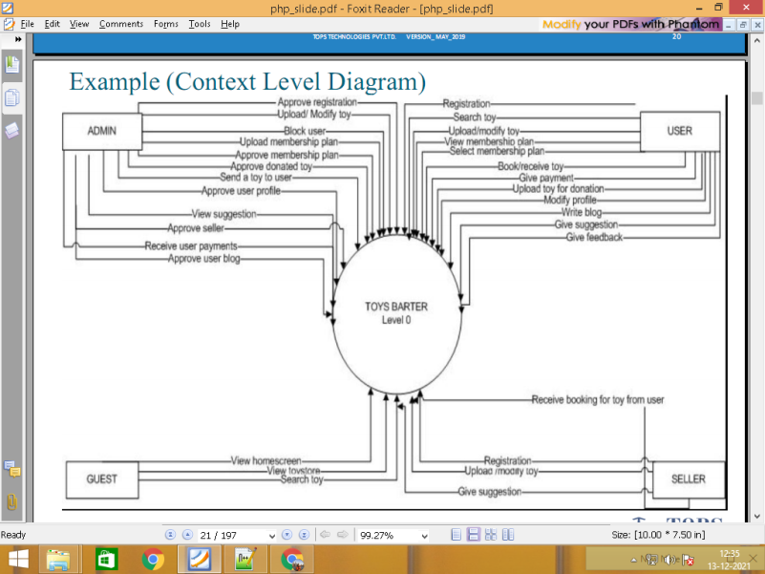

Level 1
\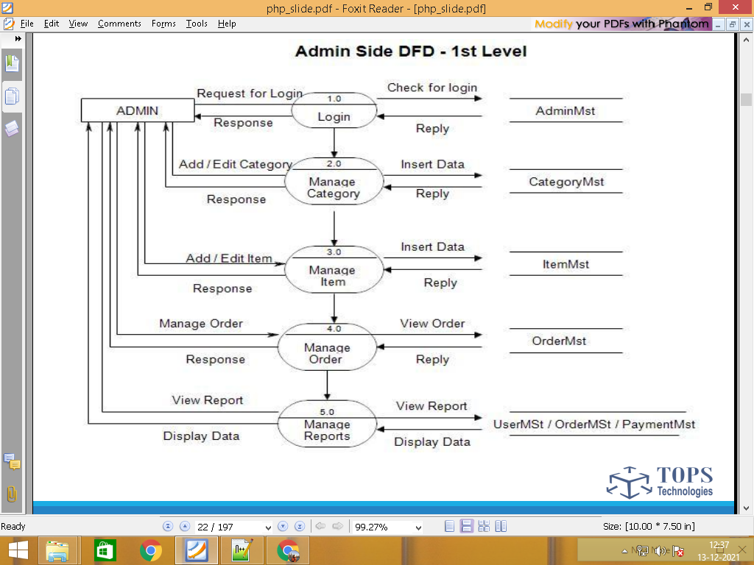

Website visit
Guest View product categories categories.tbl
View product products.tbl
Contact us contacts.tbl

Website visit
View product categories categories.tbl
View product products.tbl
Contact us contacts.tbl
Signup customers.tbl
Customer Login customers.tbl
Manage profile customers.tbl
Add to cart carts.tbl
Make Order Orders.tbl
Manage order orders.tbl
Feedback feedbacks.tbl
Logout customers.tbl

Signup by admin employees.tbl
Login employees.tbl
Manage product categories categories.tbl
Manage product products.tbl
Manage Contact us contacts.tbl
Employee Manage Customer customers.tbl
View cart report carts.tbl
Manage Order orders.tbl
View Feedback feedbacks.tbl
Logout employees.tbl

Login admin.tbl LF
Manage product categories categories.tbl T - F
Manage product products.tbl T -F
Manage Contact us contacts.tbl T
Admin Manage Customer customers.tbl T
View cart report carts.tbl T
Manage Order orders.tbl T
View Feedback feedbacks.tbl T
Manage Employee employees.tbl F -T
Logout admin.tbl

=====================================================================================

Step 5: Define Total No. of Table List

admin.tbl
categories.tbl
products.tbl
contacts.tbl
customers.tbl
carts.tbl
orders.tbl
feedbacks.tbl
employees.tbl

Step 6 : Define Each table column / Data Dictionary

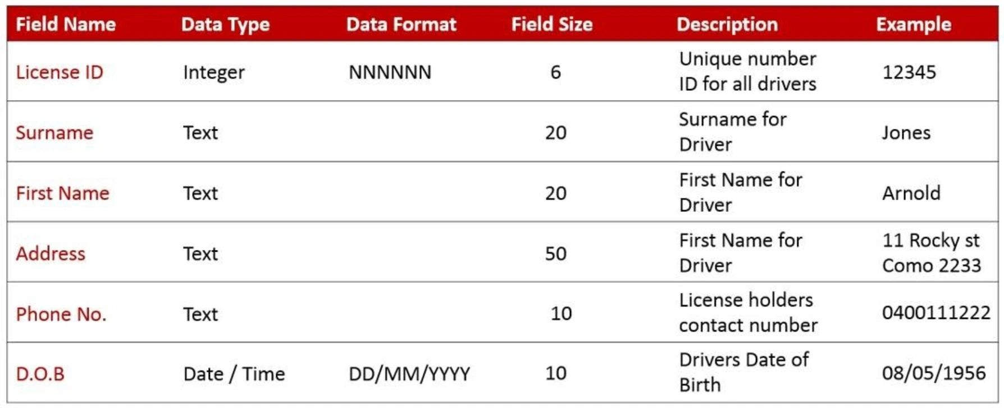

admin.tbl login 2 form

id pk auto_increement
name
email
password

categories.tbl column : 3 / form : 2

id pk auto_increement 1
name khakhara
image khakhara.jpg

10 categories

subcategories form 3 / column 4

id pk auto_increement
cate_id fk
sub_catename
sub_cateimage

products.tbl column =10 form=8

id pk auto_increement
cate_id fk
subcate_id fk
prod_name
short_desc
long_desc
main_price
disc_price
prod_image
status

contacts.tbl column 4 / form 3

id pk auto_increement
name
email
comment

customers.tbl signup form 5 / table column 7

id pk auto_increement
name
email
password
mobile
image
status automatic

carts.tbl
id pk auto_increement
prod_id fk
cust_id fk
qty
total_price

orders.tbl
id pk auto_increement
cart_id fk
cust_id fk
total_amout
address
state
city
pincode

feedbacks.tbl
id pk auto_increement
order_id fk
cust_id fk
comment

employees.tbl

id pk auto_increement
name
email
password
status

============================================================

- Designing
Database & table create / website designing
- Implementation/coding
Data add / update / delete code
- Testing
Website works without bugs or error
Testing
- Maintenance

User guide
Installation
After maintenance service
Any changes & updating

================================================

Page layout ADMIN / employee

Login.php
Dashboard
Add_task form
Manage table

Free css admin panel

MENU
1 ADD-MANAGE => DROPDOWN
2 MANAGE => SIMLE LINK WALA MENU

